UNIT I Water and its Treatment

INTRODUCTION

Water is essential for the existence of human beings, animals and plants. Though 80% of the earth’s surface is occupied by water, less than 1% of the water is available for ready use.
The main sources of water are
- Rain
- rivers and lakes (surface water)
- wells and springs (groundwater)
- seawater

Among the above sources of water, rain water is the purest form of water but it is very difficult to collect whereas sea water is the most impure form.
Thus, surface and ground water are normally used for industrial and domestic purposes. Such water must be free from undesirable impurities.

“The process of removing all types of impurities from water and making it fit for domestic or Industrial purposes are called water treatment.”

HARD WATER AND SOFTWATER

Hard Water

Water which does not produce lather with soap solution, but produces a white precipitate is called hard water. It produces a white scum or precipitate.
This is due to the presence of dissolved Ca and Mg salts.
2C₁₇ H ₃₅COONa + Ca⁺⁺ → (C₁₇ H ₃₅ COO) ₂Ca +2Na⁺
Water soluble Water insoluble

Soft Water

Water which produces lather readily with soap solution is called soft water. This is due to the absence of Ca and Mg salts.

WATER QUALITY PARAMETERS
The quality of water is very important to decide the type of application or treatment required. Quality of water will not be the same in all places and seasons.

The important water quality parameters are:
Color, odour, pH, Hardness, alkalinity, TDS, COD and BOD.

1. COLOUR
Colour is a shade imparted by organic and inorganic material which changes the appearance of water. Colour of water range from pale straw though yellowish brown or dark brown. The colour is mainly due to the presence of dissolved or colloidal organic or inorganic materials.
Sources:
Organic sources – Algae, tannins, humic compounds, organic dyes etc.,
Inorganic sources – Fe and Mn compounds, chemicals, inorganic dyes from
various industries,
Removal of colour: By using coagulants, settling, adsorption and filtration

2. TASTE AND ODOUR
Taste and odour are objectionable for various industrial processes such as food products, beverages, textiles, paper and pulp. Odour in natural waters is organic in nature except H₂S.
Sources;
Organic sources, inorganic sources, algae and decaying vegetation etc.,
Removal of Taste and odour
- By aeration or activated carbon treatment.(Organic taste and odour)
- Chemical methods like oxidation, chlorination or precipitation (Inorganic tastes due to H₂S).

3. pH
The hydrogen ion concentration is determined by the pH value
pH = -log₁₀ [H+]
pH of natural water will lie in the neutral range. For drinking water pH will be between 6.5 to 8.5.
Determination
pH meter is used to determine the pH of the water.

4. HARDNESS
Hardness is a property which prevents lathering with soap. Hardness is due to the presence of chlorides, sulphates and bicarbonates of calcium and magnesium.
Hardness is of two types - Carbonate (temporary) and Non-carbonate (Permanent) hardness
Temporary or Carbonate Hardness:
This is due to the presence of bicarbonates of Ca and Mg. It can be removed by boiling or by adding lime to the water.
The bicarbonates present in water are converted into soluble carbonates and hydroxides.
Ca(HCO₃)₂—→CaCO₃+CO₂+H₂O.
Mg(HCO₃)₂​→MgCO₃​+CO₂​+H₂​O

Permanent or Non-carbonate hardness
This is due to the presence of chlorides and sulphates of Ca and Mg. It cannot be removed by boiling. It can be removed by lime-soda process or zeolite process.
CaCl₂ + Na₂CO₃ 2NaCl +CaCO₃
CaSO₄ + Na₂Ze CaZe + Na₂SO₄

Total Hardness = Temporary hardness + Permanent hardness.

Molecular weights of some hardness producing salts.
Hardness producing salt | Molecular weight | Hardness producing salt | Molecular weight
Ca(HCO₃)₂ | 162 | MgSO₄ | 120
Mg(HCO₃)₂ | 146 | MgCO₃ | 84
Mg(NO₃)₂ | 148 | MgCl₂ | 95
Ca(NO₃)₂ | 164 | CaCl₂ | 111
CaCO₃ | 100 | Ca2+ | 40
CaSO₄ | 136 | Mg2+ | 24

Expression of hardness in terms of equivalents of CaCO₃
The amount of hardness producing salts is usually expressed in terms of an equivalent amount of CaCO₃. CaCO₃ is chosen as a standard because,
1. Its molecular weight (100) and equivalent weight (50) is a whole number, so the Calculations in water analysis can be simplified.
2. It is the most insoluble salt, that can be precipitated in water treatment. If the
concentration of hardness producing salt is x mgs/lit.then
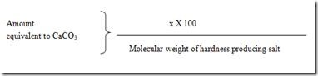
Units of Hardness
1. Parts per million(ppm)
It is defined as the number of parts of CaCO₃ equivalent hardness per 106 parts of water.

2. Milligrams per litre(mg/lit)
It is defined as the number of milligrams of CaCO₃ equivalent hardness per 1 litre of water.

3. Clarke’s degree (oCl)
It is defined as the number of parts of CaCO₃ equivalent hardness per 70,000 parts of water.

4. French degree(oFr)
It is defined as the number of parts of CaCO₃ equivalent hardness per 105 parts of water.

Relationship between various units
1ppm = 1 mg/lit = 0.10 Fr = 0.070Cl

5. ALKALINITY

Alkalinity is the acid neutralising ability of water. Depending on the anions that are responsible for the alkalinity of water, there are three types of alkalinity.

Alkalinity – due to hydroxide ions
- Carbonate alkalinity - due to carbonate ions
- Bicarbonate alkalinity - due to bicarbonate ions

The alkalinity due to hydroxide and carbonate can be detected by Phenolphthalein indicator and so they are collectively called as Phenolphthalein Alkalinity, represented by P. The alkalinity due to hydroxide, carbonate and bicarbonate can be detected by Methyl orange indicator and so it is called as in Methyl orange Alkalinity, represented by M.
Significance
- High alkalinity is harmful to aquatic organisms.
- Alkalinity in boilers will cause caustic embrittlement.
Removal of Alkalinity
By adding limited amount of HCl.

6. Total dissolved solids (TDS)

TDS represents the total concentration of dissolved organic and inorganic substances in water. It includes substances in ionized, or micro-granular (colloidal sol) suspended form.
Sources of TDS
Natural sources, sewage, urban run-off, industrial wastewater, and chemicals used in the water treatment process etc.,
Effects of TDS
It causes turbidity in water.
It causes various diseases.
It affects pipelines
Removal of TDS
By Reverse osmosis

7. BIOLOGICAL OXYGEN DEMAND (BOD)

It is defined as the amount of oxygen required for the decomposition of organic matter by bacteria. It is expressed in ppm or mg/litre.
Significance
1. It measures the amount of oxygen required for the biological decomposition of organic matter.
2. It determines the amount of organic matter present in soil, effluents etc.,
3. Used in medicinal and pharmaceutical industries to measure the amount of oxygen
consumption of cell cultures.
Measurement of BOD
It is measured using a BOD meter.

8. CHEMICAL OXYGEN DEMAND (COD)

It is defined as the amount of oxygen required to chemically oxidize biodegradable and non-biodegradable organic matter using potassium permanganate as an oxidizing agent.
It is expressed in mg/litre or ppm
Significance of COD
- To determine the organics in water
- The amount of organics in sewage water, effluents can be found.
Measurement of BOD
- Open reflux method ii. Closed reflux method

BOILER FEED WATER

Boiler is an equipment used to convert water into steam. The water used in boilers to produce steam is called boiler feed water.
Requirements for Boiler Feed Water
Type | Amount | Type | Amount
Hardness |  | Dissolved gases | 0 ppm
Soda alkalinity | 1.15 – 1 ppm | Oil & grease | Less than 0.5 ppm
Caustic alkalinity | 0.15 – 0.45 ppm | pH | 7.5 – 9.4

If hard water is used in boilers it causes some problems (troubles). They are
- Scale and sludge formation
- Priming & Foaming
- Caustic embrittlement
- Boiler corrosion

1. SCALE AND SLUDGE FORMATION
When water is continuously used in boilers concentration of dissolved in water increases. These salts will be thrown in the form of a precipitate inside the boiler.
SLUDGE:
If the precipitate formed is loose and slimy it is called sludges. Sludges are formed due to salts like MgCl₂, MgSO₄, CaCl₂ etc.,
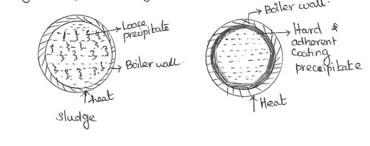

SCALES
If the precipitate formed is hard, adherent and sticks to walls of the boiler, it is called scales. Scales are formed due to salts like Ca(HCO)₃)₂, Mg(OH)₂, CaSO₄ etc.,
Disadvantages of scale formation:
1. Wastage of fuel :
Scales have a low thermal conductivity, so the rate of heat transfer from boiler to inside water is greatly decreased. In order to provide a steady supply of heat to water, excessive or over heating is carried out and this causes increase in fuel consumption. The wastage depends upon the thickness and the nature of scale.
Thickness of scale (mm) | 0.325 | 0.625 | 1.25 | 2.5 | 12
Wastage of fuel | 10% | 15% | 50% | 80% | 150%

2. Decrease in efficiency: Scales may sometimes deposit in the valves and condensers of the boiler and choke them partially. This results in decrease in efficiency of boiler.
3. Boiler explosion: When thick scales crack, due to uneven expansion, the water comes suddenly in contact with over-heated iron plates. This causes formation of a large amount of steam suddenly. So sudden high-pressure is developed, which may even cause explosion of the boiler.
Removal of scales:
- If the scales are loosely adhered to the walls scraper or a wire brush or a piece of wood can be used.
- By giving thermal shocks (i.e., heating the boiler and then suddenly cooling with cold water), if they are brittle.
- By dissolving them by adding chemicals, if they are adherent and hard. Thus, calcium carbonate scales can be dissolved by using 5-10% HCl. Calcium sulphate scales can be dissolved by adding EDTA (ethylene diamine tetra acetic acid), with which they form soluble complexes.
- By frequent blow-down operation, if the scales are loosely adhering.
Prevention of scales formation : (1) External treatment (2) Internal treatment
Differences between scales and sludges
S.No | Sludges | Scales
1 | The precipitate formed is loose and slimy | Precipitate formed will be hard and adherent
2 | Sludges are poor conductors of heat | Scales are insulators. It reduces the efficiency of the boiler
3 | Sludge formation can be prevented by using softened water | Scales are prevented by using dilute acids like HCl, H₂SO₄
4 | Sludges can be removed by blow down operation | Scales formation can be removed by external and internal treatment.
5 | Blow down process – It is a process of removing of concentrated water by fresh water frequently from the boiler during steam production. | They can be removed by applying thermal shocks, scrapers, wire brushes etc.,
2. PRIMING AND FOAMING
When steam is produced in boilers along with some droplets of water will be also carried over. This steam is called wet steam. This process is called carry over process.
Priming: The formation of wet steam is called priming. This is due to the presence of a large amount of dissolved solids.
Causes
- high steam velocities,
- sudden boiling ;
- improper boiler design
- High water level in boilers
Prevention
  - Low steam velocity
  - Uniform boiling
  - Proper boiler design
  - Low water level in boilers

Foaming
The formation of stable bubbles in the surface of water in boilers is called foaming.
Causes
1. Due to presence of substances like oils (which greatly reduce the surface tension of
water).
2. Presence of finely divided particles
Prevention

i. By adding anti-foaming chemicals like sodium aluminate, aluminium hydroxide
ii. by adding compounds like sodium aluminates.

3. CAUSTIC EMBRITTLEMENT
The intercrystalline cracking of boiler metal is called caustic embrittlement. This is due to the presence of Na₂CO₃ in water. It decomposes to form NaOH.

Na₂CO₃ + H₂O → 2NaOH + CO₂

This NaOH flows into the cracks and crevices present in the boiler. This will react with iron to form sodium ferroate.

Fe + NaOH Na₂FeO₂ + H₂
This causes brittlement in boiler parts, particularly in the joints, rivets etc.,
Prevention
i.Using sodium phosphate as softening agent instead of sodium carbonate
ii. By adding tannin, lignin to the boiler metal to block the cracks.
4. BOILER CORROSION
Boiler corrosion is decay of boiler material by a chemical or electro-chemical attack by its environment. Main reasons for boiler corrosion are:

- Dissolved oxygen
- Dissolved carbondioxide
- Dissolved salts

- Dissolved oxygen : Water usually contains dissolved oxygen. Dissolved oxygen in water, at high temperature, attacks boiler material:
2 Fe + 2H₂O + O₂ → 2 Fe(OH)₂
4 Fe(OH)₂ + O₂ → 2 (Fe₂O₃.2H₂O)
Ferrous hydroxide Rust
Removal of dissolved oxygen
- By adding chemicals:
Adding sodium sulphite
2 Na₂SO₃ + O₂ → 2 Na₂SO₄
Adding Hydrazine
N₂H₄ + O₂ → N₂ + 2 H₂O
2. By mechanical de-aeration:
Mechanical de-aerator is used. It is a large tower containing plates. High temperature and low pressure is maintained. Under this condition the dissolved oxygen in water will be removed.
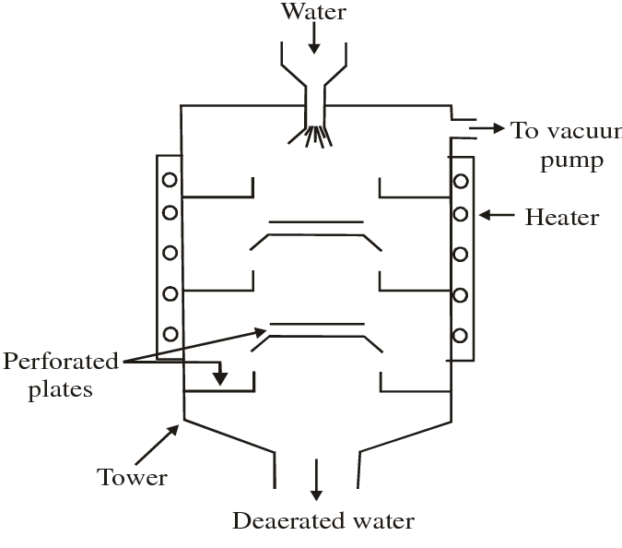
2. Dissolved carbon dioxide :
Carbondioxide present in water will form carbonic acid.
CO₂ + H₂O → H₂CO₃
Carbondioxide will be formed due to bicarbonate salts in water.
Mg(HCO₃)₂ → MgCO₃ + H₂O + CO₂
Removal of CO₂ :
- By adding calculated quantity of ammonia.
2NH₄OH + CO₂ → (NH₄)₂CO₃ + H₂O
(2) By mechanical-deaeration process along with oxygen.
(3) Dissolved salts:
Water containing dissolved magnesium salts liberate acids on hydrolysis, e.g.,
MgCl₂ + 2H₂O → Mg(OH)₂ + 2HCl
The liberated acid reacts with iron (of the boiler) in chain like reactions producing HCI again and again. Thus
Fe + 2HCI → FeCl₂ + H₂
FeCl₂ + 2H₂O → Fe(OH)₂ + 2HCl
Consequently, presence of even a small amount of MgCl₂ will cause corrosion of iron to a large extent.
Removal of acids
By adding an alkali to the boiler water
HCl + NaOH NaCl + H₂O
Softening or Conditioning of Water
The process of converting hard water to soft water is called conditioning or softening of water.
It is of two types
1. Internal conditioning or internal treatment
2. External conditioning or external treatment

I. INTERNAL CONDITIONING OR INTERNAL TREATMENT OF WATER
In this method the chemicals are directly added into the boiler to remove hardness causing salts. The chemicals added in this process are called boiler compounds.
It can be done by four methods
- Carbonate conditioning
- Phosphate conditioning
- Calgon conditioning
- Colloidal conditioning

Carbonate conditioning

- This method is used in low pressure boilers
- Sodium carbonate is added
- Sodium carbonate added will combine with the hardness causing salts and form calcium carbonate which can be removed easily.

CaSO₄+Na₂CO₃ → CaCO₃+Na₂SO₄

Phosphate conditioning

- This method is used in high pressure boilers.
- Sodium phosphate is added in this method.
- The sodium phosphate added will form calcium phosphate which is soluble.

3CaSO₄+2Na₃PO₄ → Ca₃(PO₄)₂ +3Na₂SO₄

- Different phosphates can be used – Trisodium phosphate, disodium hydrogen
- phosphate, sodium dihydrogen phosphate

Trisodium phosphate - used for too acidic water
Disodium hydrogen phosphate - used for weakly acidic water.
Sodium dihydrogen phosphate - used for alkaline water.

Calgon conditioning

- This method is used in high pressure boilers
- Calgon is sodium hexa meta phosphate (Na₂[Na₄(PO₃)₆ )
- It reacts with the calcium ions and forms a soluble complex.

CaSO₄+Na₂[Na₄(PO₃)₆ → Na₂[Ca₂(PO₃)₆]+2Na₂SO₄
Soluble
EXTERNAL CONDITIONING
In this method water is softened before it is used in boilers. This method is called external conditioning.
This is done by two methods
- Zeolite process (Permutit Process)
- Ion exchange process
1. ZEOLITE PROCESS (PERMUTIT PROCESS)
Zeolites are hydrated sodium alumino silicate. Its general formula is Na₂O.Al₂O₃. xSiO₂. yH₂O (x=2, y= 2-6). There are two types of zeolites – natural and synthetic. Natural zeolite is green sand. Green sand will be non-porous. It cannot be used in softening. Synthetic zeolite will be porous and has a gel structure. So it is used in softening.
Process
This equipment is a large tower packed with zeolite bed. There is an inlet to pass hard water and another inlet at the top to add NaCl for regeneration of Zeolite bed. When hard water is passed through the cylinder all the positive ions present in hard water will be removed.
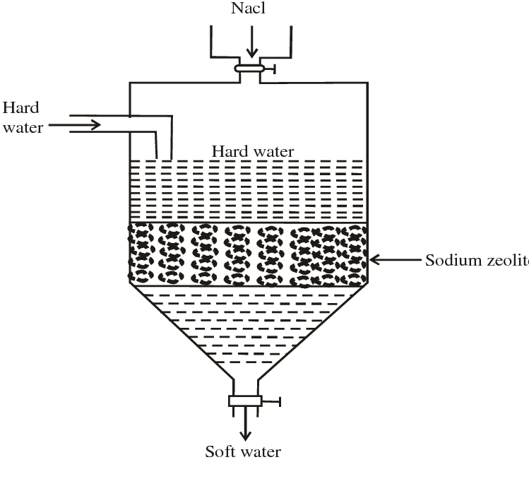
Reactions
Ca(HCO₃)₂ + Na₂Ze → CaZe + 2NaHCO₃
Mg(HCO₃)₂ + Na₂Ze → MgZe + 2NaHCO₃
CaSO₄ + Na₂Ze → CaZe + Na₂SO₄
MgSO₄ + Na₂Ze → MgZe + Na₂SO₄
CaCl₂ + Na₂Ze → CaZe + 2NaCl
MgCl₂ + Na₂Ze → MgZe + 2NaCl
The water coming out will have large amount of sodium salts. Hence this water cannot be used in boilers.
Regeneration
When this process is carried for a long time, the zeolite becomes inactive. It is said to be exhausted. Hence NaCl is added for regeneration.
CaZe + 2NaCl → Na₂Ze + CaCl₂
MgZe + 2NaCl → Na₂Ze + MgCl₂
Advantages
- The water coming out will have less hardness (< 2 ppm)
- Equipment is compact.
- Process is simple.
- Its operation is easy.
Disadvantages
- Turbid water cannot be used.
- Water softened in this method cannot be used in boilers because it causes caustic embrittlement.
- Only positive ions can be removed.

2. ION EXCHANGE PROCESS (DEMINERALIZATION PROCESS)
In this process almost all the ions present in water will be removed. This removes hardness causing ions like Ca ²⁺, Mg²⁺ and also other ions like Na⁺, K⁺, SO₄²⁻ etc.,. The demineralized water does not contain any ions.
Process
- In this method, resins are used.
- Resins are long chain hydrocarbons with a micro-porous structure.
- Resins are of two types – Acidic resin and basic resin.
- Acid resins will have one more replaceable hydrogen ions. Eg: sulphonated coals, sulphonated polystryrene
- Basic resins will have one or more replaceable hydroxide ions. Eg: Urea-formaldehyde resin, quaternary ammonium salts.
- Ion exchanger has two cylinders – Cylinder I & cylinder II.
  - 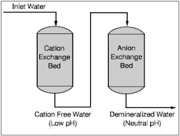
- Cylinder I will be packed with acid resin.
- Cylinder II will be packed with basic resin.
- When hard water is passed through cylinder I all the positive ions present in water will be removed.
CaCl₂ + RH₂ → RCa + 2HCl
MgSO₄ + RH₂ → RMg + H₂SO₄
- The same water is passed through cylinder II. All the negative ions present in
water will be removed.
R’(OH)₂ + 2HCl→ 2R’Cl + 2H₂O
R’(OH)₂ + 2H₂SO₄→ 2R’SO₄ + 2H₂O
- The water coming out from cylinder II will be free from ions. This water is called deionized water or dimineralised water.
Regeneration of resins
When this process is used for a long time the resins will become inactive. So dil HCl is added in cylinder I and NaOH is added in Cylinder II
Cylinder I
RCa + 2HCl → RH₂ + CaCl₂
RMg + 2HCl → RH₂ + MgCl₂
Cylinder II
R’SO₄+2NaOH → R’(OH)₂ + Na₂SO₄
R’Cl₂+2NaOH → R’(OH)₂ + 2NaCl
Advantages
- The water coming out will have less hardness (< 2 ppm)
- All ions will be removed.
Disadvantages
- Turbid water cannot be treated.
- Equipment and chemical cost will be high.

MUNICIPAL WATER OR POTABLE WATER
The main characteristics of potable water are,
- It should be colourless, odourless and clear
- It should be pleasant to taste.
- It should be free from disease causing bacteria and suspended impurities.
- Hardness should be less than 500 ppm.
- Chloride content should be less than 250 ppm.
- pH should be between 6.5 – 8.5
- Flouride content should be less than 1.5 ppm
- TDS should be less than 500 ppm
- It should be cool.
- It should be free from dissolved gases like CO₂, H₂S, NH₃ etc.,

STEPS INVOLVED IN THE TREATMENT OF MUNICIPAL WATER OR POTABLE WATER
Potable water should be free from colloidal impurities, suspended impurities, industrial effluents and disease causing bacteria.
Aeration
Screening
Sources of water

Sedimentation
Coagulation
Filtration

Sterilisation (or) Disinfection

Primary or Preliminary treatment
- Screening
Floating materials like leaves, wooden pieces etc., can be removed in this step. Water is passed through large screens with holes. Impurities will be retained in the screens.
- Aeration
Air is passed in this step. Aeration is done to
- Removes gases like CO₂, H₂S etc., and volatile impurities present.
- Removes ferrous and manganese salts as insoluble ferric and manganic salts.
- Sedimentation
In this step suspended impurities are removed. Water is allowed to stand in large tanks for 2-6 hrs. All the suspended impurities will settle due to gravity. Only 75% of suspended impurities can be removed in this method.
- Coagulation
Finely divided clay, silica do not settle easily. Such impurities can be removed by coagulation. Coagulants like alum, Al(SO₄)₃ will be added to water. It forms a white gelatinous precipitate of aluminum hydroxide, Al(OH)₃. This precipitate will entrap all the colloidal impurities in water and settle at the bottom and can be removed easily.
Coagulants like alum or ferrous sulphate is added to speed up the settling process.
Al₂(SO₄)₃ + 6 H₂O 2 Al(OH)₃ + 3 H₂SO₄

Secondary or Biological treatment
Biodegradable organic impurities are removed in this method. Aerobic bacteria are used. Around 90% oxygen demanding waste will be removed. Trickling filter process or activated sludge process can be used in this step.
Trickling filter process

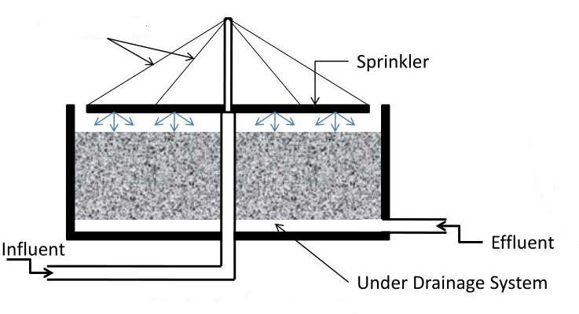

It is a circular tank filled with either coarse or crushed rock. Sewage is sprayed over this bed by means of slowly rotating arms. When sewage starts percolating downwards, microorganisms present in the sewage grow on the filtering media using organic material of the sewage as food. After completion of aerobic oxidation the treated sewage is taken to the settling tank and the sludge is removed. This process removes around 80-85% BOD.

Activated sludge process

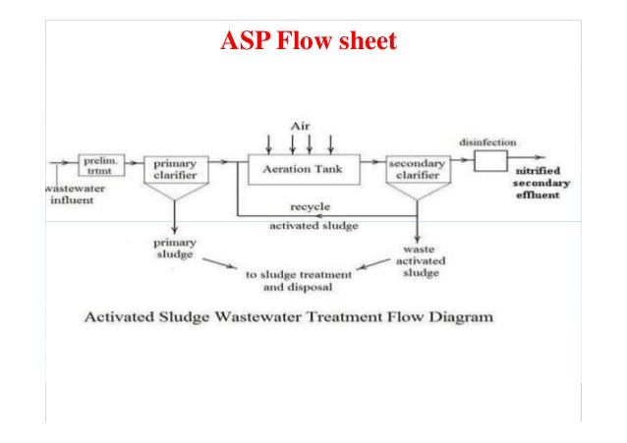

Activated sludge is biologically active sewage and it has large number of aerobic bacteria, which can easily oxidize the organic impurities. The sewage effluent from primary treatment is mixed with the required amount of activated sludge. Then the mixture is aerated in the aeration tank. Under this condition, organic impurities of the sewage get oxidized rapidly by the microorganisms.
After aeration the sewage is taken to the sedimentation tank. Sludges settle down in this tank called activated sludge. A portion of this can be reused to continue the process.. This process removes around 90=95% of BOD.

Tertiary treatment
In the tertiary treatment the effluent is passed into a flocculation tank. Lime will be added to remove the phosphates. pH is maintained at 11. Then the effluent is allowed to pass into activated charcoal column where minute organic wastes are absorbed by charcoal. Finally chlorine is added for disinfection. The process of killing harmful bacteria present in water is called sterilization or disinfection.
Disinfection is done by chlorination, ozonolysis and UV treatment.
1. Chlorination:
The process of adding chlorine to water is called Chlorination. It is done by
- Adding chlorine directly
Cl₂+ H₂O → HCl+ HOCl
Bacteria+ HOCl → Bacteria are destroyed
- By adding chloramines
Chloramine is produced by mixing chlorine and ammonia in the ratio 2:1
Cl₂+ NH₃ → ClNH₂+ HCl
Chloramine formed will decompose to form chlorine which will kill the bacteria present in water.
- By adding bleaching powder
When bleaching powder is added it form hypochlorous acid which will destroy the bacteria present in water,
CaOCl₂+ H₂O → Ca(OH)₂+Cl₂
Cl₂+ H₂O → HCl+ HOCl
Germs + HOCl → Germs are killed

2. Ozonolysis
Ozone is a powerful disinfectant. It will be absorbed by water. It is highly unstable and it gives nascent oxygen.
O₃ O₂ + [O]
Nascent oxygen is a powerful oxidizing agent which kills bacteria.

3. UV Treatment
When electric current is passed through a mercury vapour lamp it gives UV rays. This method is generally used to sterilize swimming pools.
Disadvantages – It is costly and turbid water cannot be treated.

DESALINATION
The process of removing common (sodium chloride) salt from sea water is called desalination. The water containing dissolved salts with a peculiar salty taste is called brackish water.
Depending upon the quantity of dissolved solids, water is graded as
Fresh water – contains <1000 ppm of dissolved solids
Brackish water – contains > 1000 but <35,000 ppm of dissolved salts
Sea water – contains > 35,000 ppm of dissolved salts.

Desalination is done by reverse osmosis
Reverse Osmosis
- Osmosis is a process in which a solvent from a region or low concentration to high concentration through a semi-permeable membrane. Pressure exerted is called osmotic pressure.
- When a pressure greater than osmotic pressure is applied solvent flows from high concentration to low concentration. This process is called reverse osmosis(super filtration or hyper filtration).
- A tank is taken.
- It is divided into two compartments.
- One side of the compartment is filled with sea water and the other side with pure water.
- A semi-permeable membrane is attached at the centre.
- A piston is attached on the top to apply pressure.
- A pressure greater than osmotic pressure is applied.
- Now water flows from sea water side to pure water side.
- Pure water is collected through the outlet.
- The common membranes used are cellulose acetate, cellulose butyrate etc.,
- When the membrane is used for a long period it should be replaced. A new membrane will be replaced which takes only few minutes.
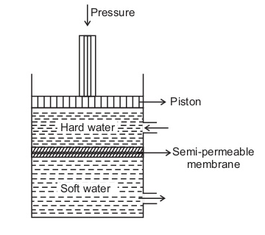
Advantages
- It removes all ionic, non-ionic and colloidal impurities
- The membrane can be replaced within few minutes
- Simple and low capital cost.

